Light Gauge Steel Components & Assembly Overview [1]
In a light gauge steel panel, the components can be majorly categorized in three categories i,e. the members, the panel assembly itself and the connectors.
- Members are the very fundamental components used to make a rigid frame. This group mainly consists of vertical studs which are the C-shaped sections that bear vertical and lateral loads; horizontal track members which are U-shaped channels that anchor the studs at the top and bottom and then floor and roof joists that run between tracks and miscellaneous diagonal braces or tension straps that stabilize the assembly against racking. For truss assemblies, the chords help frame the top and bottom edges of trusses. There are also reinforced studs like jam studs, boxed studs and other sections like headers around openings to amp up the overall stiffness of the frame.
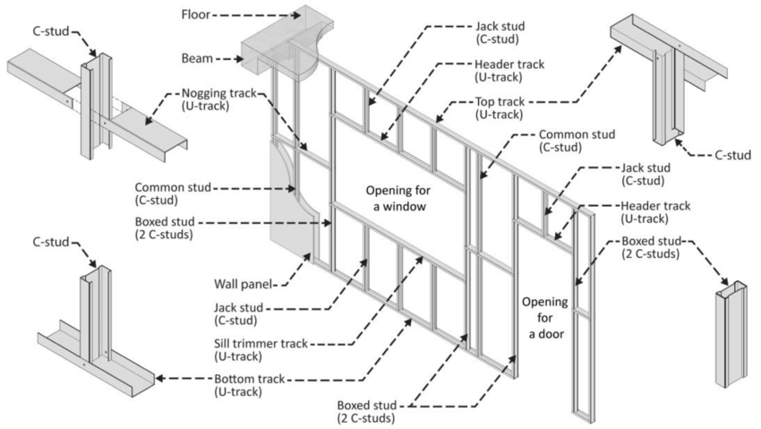

- The assemblies combine members into a single functional unit. A wall panel is simply a grid of studs locked into top and bottom tracks optionally with diagonal braces for stability. A floor panel or cassette arranges parallel joists into tracks and while a roof or truss assembly adds top and bottom chords and a pattern of diagonal steel webs.

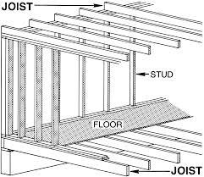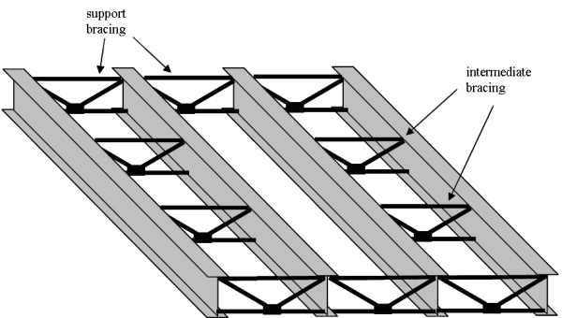
- In cold-formed-light-gauge-steel (LGS) frames, the most common connector are the screws (different types for different applications/scenarios). In heavier applications bolts or rivets may appear but they are not as common. Clips, brackets and angle connectors show up wherever two members must frame the same corner or the screw’s trajectory is compromised. When panels ride down to a concrete slab for lateral stability certain expansion or adhesive anchors slap securely into the slab to tie everything to the floor. Together, these commonly-ordered components dictate the geometry and strength of the entire framing scheme.
In summary we can contain our use case into the following:
LGS Components & Categories [1]
a) Members (Primary framing elements)
- Studs : vertical C-sections (load bearing)
- Tracks : Horizontal U-sections (top & bottom of panels)
- Joists : Horizontal C-sections in floors/roofs
- Chords : top/bottom members in trusses/panels (less freq)
- Braces/Straps : diagonal steel strips for stability
- Blocking/Rims : edge members, load transfer at perimeters
b) Panels (Assemblies)
- Wall panels
- Floor cassettes/panels
- Roof trusses
c) Connectors
- Fasteners : self-drilling screws, bolts, rivets.
- Clips/Brackets/Angles : indirect connections between members or to other frames like timber or drywall.
- Anchors : fix panels to concreter bases.

IFC Mapping to Key Elements
Members to IfcMember
- Types: IfcMemberTypeEnum = STUD, JOIST, BRACE else USERDEFINED (TRACK, CHORD).
- Profiles: IfcCShapeProfileDef, IfcUShapeProfileDef, IfcParameterizedProfileDef.
Panels to IfcElementAssembly
- PredefinedType: USERDEFINED
- Decomposition: IfcRelAggregates links the assembly to members & connectors.
Connectors to IfcMechanicalFastener/IfcFastener
- Screws/Bolts/Rivets : IfcMechanicalFastener (PredefinedType = SCREW, BOLT, RIVET).
- Clips/Brackets : IfcFastener (PredefinedType = CLIP, BRACKET, GUSSET).
- Anchors to concrete : IfcMechanicalFastener (ANCHOR).
Connections & Relations
a) Member-to-Member Connections
Direct connections (steel-to-steel contact)
- Stud & Track : screws (most common) or welds (very rare).
- Stud & Stud : back-to-back (double studs) OR nested studs (box studs).
- Brace/Strap to Studs/Tracks : flat strap fastened with screws at ends.
IFC Representation
- IfcRelConnectsElements (RelatingElement = MemberA, RelatedElement = MemberB)
Indirect connections (via intermediate hardware)
- Clips / Angles / Brackets : transfer loads when direct screw fastening isn’t possible.
  - Example: joist end to track using an L-shaped stiff clip or joist hangers.
- Connector plates : join members at non-orthogonal angles (non 90 ° angles).
IFC Representation
- IfcFastener (CLIP/BRACKET)
- Connector itself links to each member via IfcRelConnectsElements
b) Member-to-Panel Assembly
- Members are part of a Panel (IfcElementAssembly).
IFC Relation: IfcRelAggregates (Spatial Containment relation).
c) Panel-to-Other Frames
- To Concrete Slab
Bottom track anchored with IfcMechanicalFastener (ANCHOR), linked via IfcRelConnectsWithRealizingElements.
- To Timber
- To Drywall/Non-structural frames

REFERENCES
[1] “Light Gauge Metal Framing - A Sustainable Alternative to Wood.” https://pdhonline.com/courses/c771/c771handout.pdf
[2]

